

**Vatican Solutions:**

***General Overview***

**Contents**

**Pg. 3 - Problem Overview and Major Requirements**

**Pg. 4 - Features of system**

**Pg. 7 - System Overview**

**Pg. 8 - Economic Feasibility**

**Problem Overview**

* Currently, Karoline’s business process is relatively labor intensive, thus it takes away time from her baking.
* Some of the activities taking away this time are: customer communication, order taking, and administrative tasks.
* We want to help Karoline by providing a system solution that automates some of these tasks, so Karoline may primarily focus on her baking.

**Major Requirements**

* The new system shall create customers.
* The new system shall create orders.
* The new system shall track supplies.
* The new system shall track expenses.
* The new system shall provide an easy, efficient way to browse products.

**Features**

Below are a few features you can expect to see in the finished system:

* Customer creation form

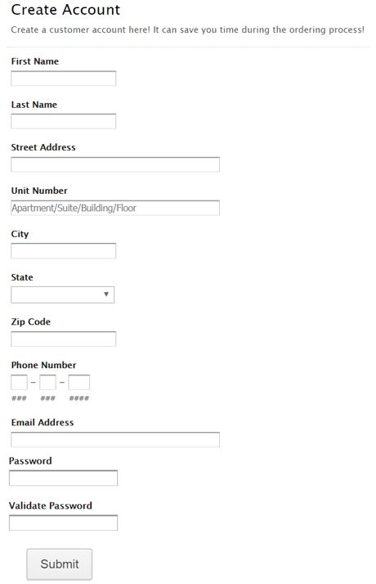

* Order form

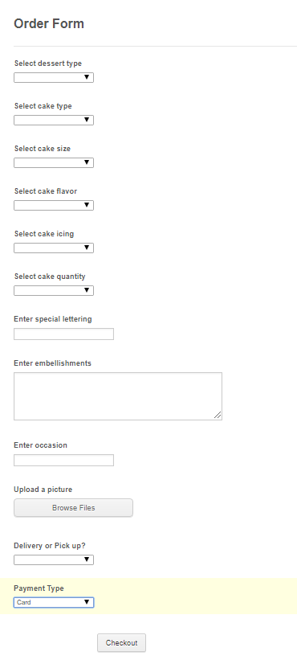

* Product view

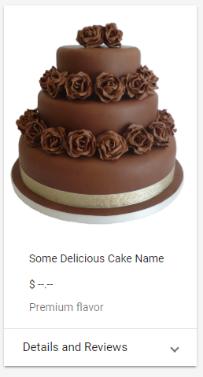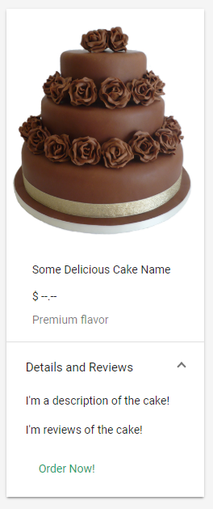

**System Overview:**

* Since the large part of your system architecture is hosted in the cloud, you don’t have to worry about security, backup, and up keep of your servers.
* SiteGround, Azure, Joomla!, and Square have a large community of users and helpful customer support professionals.

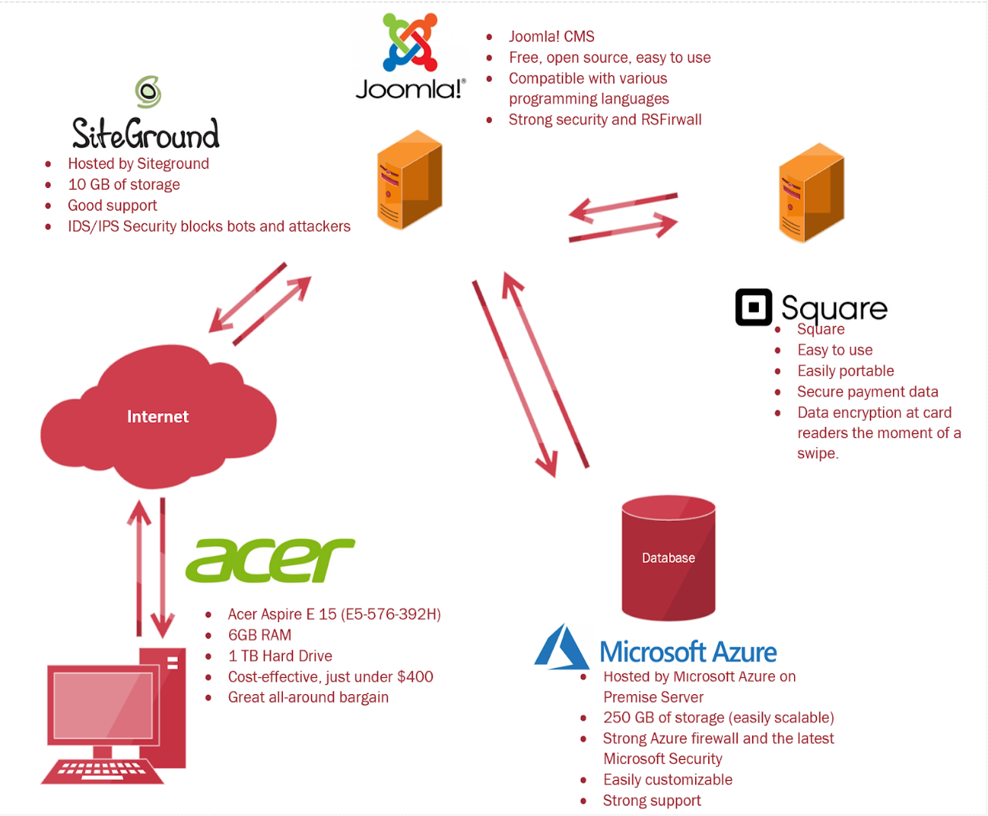

**Economic Feasibility**

Costs:

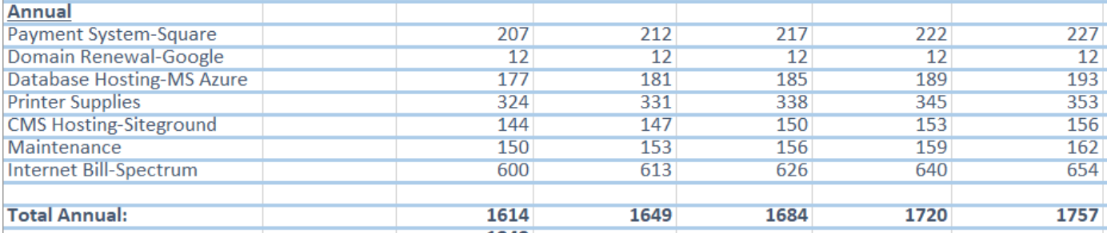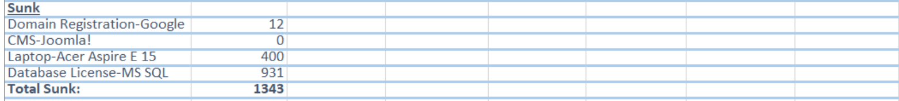

Benefits:

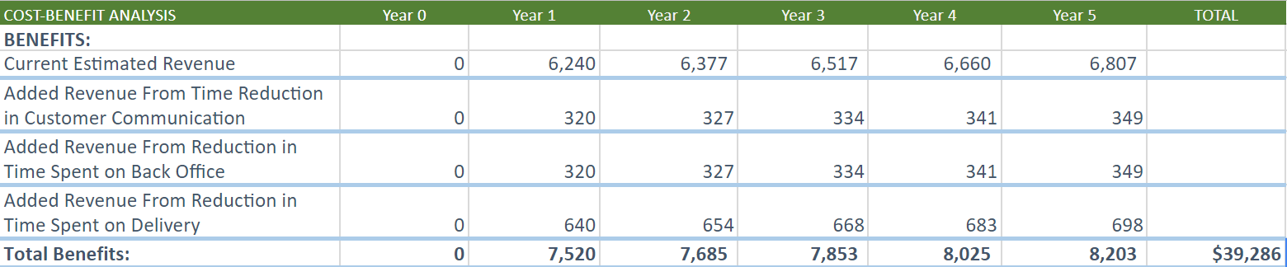

$29,519 in Total Net Benefits!

* + Break Even Point: ~**1 yr**
  + Return on Investment: **302%** (standard 5 yr period)
  + Total Net Benefits after 5 yr period… **$29,519!**